Title and subtitle
(maximum of 100 characters including spaces)
Author1 first name and surname1 (Orcid code), Author1 first name and surname2
(Orcid code), Author, Author3 first name and surname³ (Orcid code).

¹ Author1 Affiliation, University name, mail
² Author2 Affiliation, University name, mail
³ Author3 Affiliation, University name, mail
Abstract. English language, maximum 1500 characters including spaces.
Keywords: Five keywords, British English language, separated by slash (/)
1. Introduction
The minimum extension for a Full paper is 16.000 characters, its maximum extension is 20.000 spaces included (abstract, footnotes and references excluded).
For the Junior Track shortpapers the extension is 8/10.000 characters, spaces included (abstract, footnotes and references excluded).
Files must be saved as .doc, .docx file format (no .pdf).
Paper must be submitted in English, Calibri point 10 black types, using the following document as a template and applying the provided styles.
Do not use any other automatic formatting such as ‘styles’, tables or headers/footers nor particular character styles such as bold and underlining, unless italic. Do not use any automatic paragraphing tools and no indenting or numbering.
Do not number the pages of the manuscript.
Please structure the document in numbered paragraphs.

1.1. Character style-cursive
The cursive should be used throughout the manuscript for the following:

- Highlighting a term or expression;
- The name or title of a specific work or a product;
- Foreign language terms;
- Citing the title of a book or journal (including journal names) within the text;
- Title of exhibitions and events mentioned in the text.

1.2. Exceptions
For documents that for the reason of content require special character types other than indicated above, the author needs to state and inform the editors of any such requirements at the time of submission.

1.3. Footnotes
Footnotes must be used only when strictly necessary for information that is complementary to the text. Footnotes containing only references are not allowed. These must be listed at the end of the article, in the “References” list.
If necessary, insert the footnote using the command.
2. Quotations, Referencing and Bibliography
The references must be listed at the end of the text, in alphabetical order, Times New Roman point 12, and with simple spacing. References must follow the rules below: Quotation mode, referencing and bibliography should follow and be organized according to the latest version of APA Style, which can be consulted under www.apastyle.org.
The APA style foresees footnotes instead of endnotes.

Short quotations (up to 40 words) within the text should be marked by double quotations marks “..”, use […] inside the direct quotation when there is a gap. Longer quotations should follow space and be indented from the text without quotations marks:

Longer quotations should follow a space and be indented from the text without quotations marks. Longer quotations should follow a space and be indented from the text without quotations marks. Longer quotations should follow a space and be indented from the text without quotations marks. (Surname, year, p. 00)

2.1. References list
The reference list at the end of the text should report exclusively the titles cited within the paper, it is not considered a generic bibliography.

Please carefully follow APA Style formatting (latest update):
https://apastyle.apa.org/style-grammar-guidelines/references/examples

Main examples:

(Whole authored book)
Sapolsky, R. M. (2017). Behave: The biology of humans at our best and worst. Penguin Books.

(Chapter in an edited book)
Aron, L., Botella, M., & Lubart, T. (2019). Culinary arts: Talent and their development. In R. F. Subotnik, P. Olszewski-Kubilius, & F. C. Worrell (Eds.), The psychology of high performance: Developing human potential into domain-specific talent (pp. 345-359). American Psychological Association.

(Journal article)
Grady, J. S., Her, M., Moreno, G., Perez, C., & Yelinek, J. (2019). Emotions in storybooks: A comparison of storybooks that represent ethnic and racial groups in the United States. Psychology of Popular Media Culture, 8 (3), 207-217.
3. Abbreviations
Abbreviations consisting of initials (such as CEP) should omit the full stops and include expansion of the abbreviation at the first mention (Calcolatrice Elettronica Pisana (CEP)).
Should the use of abbreviations within the document be extensive, it is advisable to include an abbreviation key at the beginning of the text.
Do not use op.cit.; ibid.; ibidem; id.; idem. Do not use apud. Use the term in rather than apud.
4. Figures and Figure Legends
Manuscripts might be accompanied by up to ten images each. Images, inserted in the text, should also be uploaded and sent in separated numbered files in .jpg format and their resolution should not be lower than 300 dpi, minimum width 12cm. The captions are to be added under each image and, clearly referring to the individual image should not exceed 24 words per image. If you need to explicitly refer to an image, insert (Fig. 1) within the text. The captions must follow the below form:

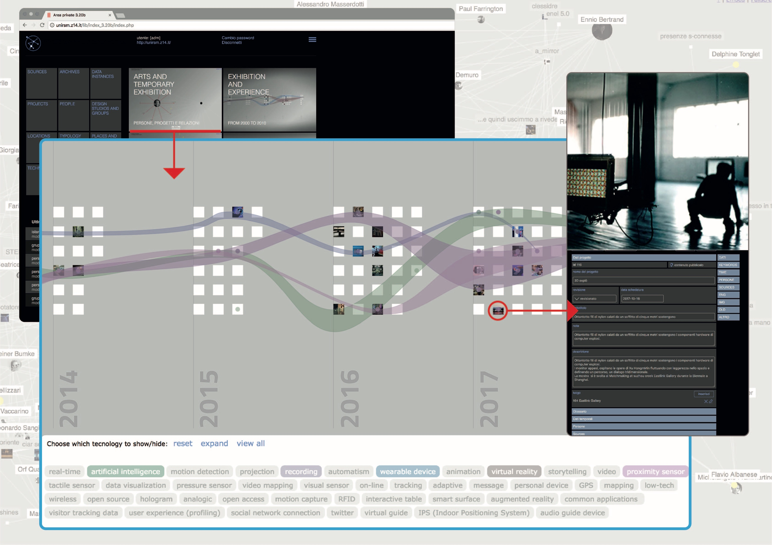

Fig 1. Author/designer, name of the project or event, short description, producer, year. (Source, acknowledgements and/or credits).

5. Author/s information
Authors have to submit a separated text file with:

- title of the paper,
- author/s name and surname,
- institutional affiliation,
- Orcid code,
- e-mail address
- and a short bio of each author (maximum 1000 characters spaces included).

6. Sending
Once ready, please upload this template (as .doc or .docx) through your 2CO3 easyChair account. In order to do that:
1) log-in as “author”
2) get to the “My Submissions for 2CO” section of easyChair
3) click on the view icon 🔎
4) click on the “upload file” option in the upper right menu

References list example
Anceschi, G. (1992). L’oggetto della raffigurazione. Milan, Italy: Etas.
Bagni, G. T. (2007). Rappresentare la matematica. Rome, Italy: Aracne.
Bonsiepe, G. (1999). Visual/Verbal Rhetoric. In Bierut, M., Helfand, J., Heller, S., & Poynor, R. (Eds.), Looking closer 3. Classic writings on graphic design. New York, United States: Allworth Communications.
Digregorio, M. R. (2011), Gli Elementi di Byrne e il ruolo del diagramma nella didattica della matematica. In Progetto Grafico, volume 20, Milan, Italy: AIAP.
Kinross, R. (1989), The Rhetoric of Neutrality. In Margolin, V. (Ed.), Design Discourse. Chicago, United States: University of Chicago Press.
Lussu, G. (2007), Tipografia e oltre. In V. Bucchetti (Ed.), Culture visive. Contributi per il design della comunicazione. Milan, Italy: Poli.design.
Peirce, C. S. (2005), Pensiero e scrittura, MS 956. In Marietti, S. (Ed.) Un passo inedito dai quaderni del filosofo circa il rapporto tra pensiero e scrittura. Riproduzione del manoscritto, testo inglese, traduzione italiana e introduzione, Rivista di filologia cognitiva, volume 3. Retrieved from: http://filologiacognitiva.let.uniroma1.it/peircei.html

Footnote.

