Template: how to submit your final paper Contributions to 2CO
Alphonzo Smith1 and John Grandson1

1 University, Department, Address, Country
{alphonzo.smith, john.grandson}@university.edu
Abstract. The abstract should summarizes the contents of the paper. Please use the abstract you have already submitted (inserting changes if needed) and that has been accapted. The abstract should be set in 9-point font size and should be inset 1.0 cm from the right and left margins. There should be two blank (10-point) lines before and after the abstract. This document is a template in the correct format.
Keywords: We would like to encourage you to list your keywords in this section (3 Keywords / divided by slash)
1 Introduction
This instruction file should be used as a template. Papers must be written in English. Please do not include header or footer in your document and please refer to styles and formatting embedded in the present document.

Maximum length: 18.000 characters (with spaces).

2 Paper Preparation
The printing area for this document is 122 mm × 193 mm. Text should be justified to occupy the full line width, so that the right margin is not ragged, with words hyphenated as appropriate. If possible please fill pages so that the text's length is no less than 180 mm.
Use 10-point type for the name(s) of the author(s) and 9-point type for the address(es) and the abstract. 10-point type and single-line spacing should be used for the main text. We recommend the use of the font New Times Roman. Italic type may be used to emphasize words in running text. Bold type and underlining should be avoided.
Papers not complying with this style will be reformatted, whichcan lead to unwanted problems. Please do use the template.
Headings. Headings should be capitalized (i.e., nouns, verbs, and all other words except articles, prepositions, and conjunctions should be set with an initial capital) and should, with the exception of the title, be aligned to the left. Words joined by a hyphen are subject to a special rule. If the first word can stand alone, the second word should be capitalized. The font sizes are given in Table 1.
Here are some examples of headings: "Criteria to Disprove Context-Freeness of Collage Languages", "On Correcting the Intrusion of Tracing Non-deterministic Programs by Software", "A User-Friendly and Extendable Data Distribution System", "Multi-flip Networks: Parallelizing GenSAT", "Self-determinations of Man".
Table 1. Font sizes of headings. Table captions should always be positioned above the tables.
Heading level | Example | Font size and style
Title (centered) | Title … | 14 point, bold
1st-level heading | 1 Introduction | 12 point, bold
2nd-level heading | 2.1 Printing Area | 10 point, bold
3rd-level heading | Headings. Text follows … | 10 point, bold
4th-level heading | Remark. Text follows … | 10 point, italic

Lemmas, Propositions, and Theorems. The numbers accorded to lemmas, propositions, and theorems, etc. should appear in consecutive order, starting with Lemma 1, and not, for example, with Lemma 11.
2.1 Figures
It is the author's task to make sure that the images are of appropriate quality.
Figures should be numbered and should have a caption which should always be positioned under the figures. Please center the captions between the margins and set them in 9-point type (Fig. 1 shows an example). The distance between text and figure should be about 8 mm, the distance between figure and caption about 6 mm.
To ensure that the reproduction of your illustrations is of a reasonable quality; if screenshots are necessary, please make sure that you are happy with the print quality before you send the files.
All used images (any raster of vector, formats TIFF, JPG or PDF) should be sent also on a separate file (.zip, .sit or .rar format).
For any issue concerning resolution, file size, tile type feel free to contact the editors: cturri@uniss.it
Remark 1. In the printed volumes, illustrations will be generally black and white (halftones), whilst colored pictures will be used in the electronic version. Please make sure that colored figures are really are legible (good contrast) also in black and white. Some colors show up very poorly when printed in black and white.

Fig. 1. Frame from 'El Hormigon Armado en Espana'. Informative animation film. AnimazioneDesign Lab. Alghero.
2.2 Footnotes
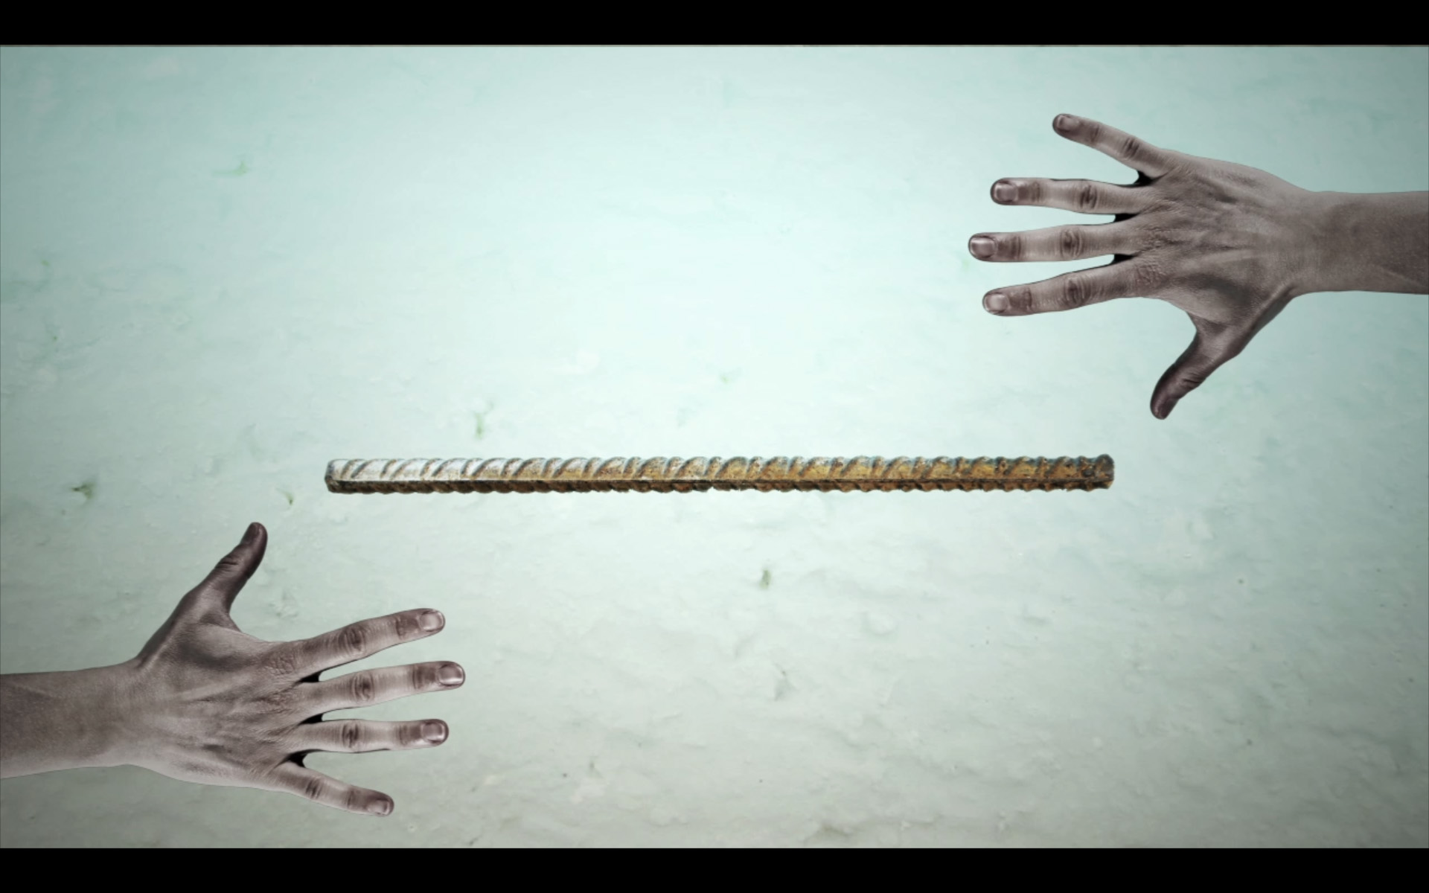
The superscript numeral used to refer to a footnote appears in the text either directly after the word to be discussed or – in relation to a phrase or a sentence – following the punctuation mark (comma, semicolon, or period). Footnotes should appear at the bottom of the normal text area, with a line of about 5cm set immediately above them.
2.3 Citations
For citations in the text please use square brackets and consecutive numbers: [1], [2], [3], etc.
2.4 Page Numbering and Running Heads
There is no need to include page numbers. If your paper title is too long to serve as a running head, it will be shortened. Your suggestion as to how to shorten it would be most welcome.
3 The References Section
Please base your references on the examples below. You should check your references thoroughly when you receive the final pdf of your paper. The reference section must be complete. You may not omit references. Instructions as to where to find a fuller version of the references are not permissible.
We only accept references written using the latin alphabet. If the title of the book you are referring to is in Russian or Chinese, then please write (in Russian) or (in Chinese) at the end of the transcript or translation of the title.
The following section shows a sample reference list with entries for journal articles [1], an LNCS chapter [2], a book [3], proceedings without editors [4] and [5], as well as a URL [6].
References
1. Smith, T.F., Waterman, M.S.: Identification of Common Molecular Subsequences. J. Mol. Biol. 147, 195--197 (1981)
2. May, P., Ehrlich, H.C., Steinke, T.: ZIB Structure Prediction Pipeline: Composing a Complex Biological Workflow through Web Services. In: Nagel, W.E., Walter, W.V., Lehner, W. (eds.) Euro-Par 2006. LNCS, vol. 4128, pp. 1148--1158. Springer, Heidelberg (2006)
3. Foster, I., Kesselman, C.: The Grid: Blueprint for a New Computing Infrastructure. Morgan Kaufmann, San Francisco (1999)
4. Czajkowski, K., Fitzgerald, S., Foster, I., Kesselman, C.: Grid Information Services for Distributed Resource Sharing. In: 10th IEEE International Symposium on High Performance Distributed Computing, pp. 181--184. IEEE Press, New York (2001)
5. Foster, I., Kesselman, C., Nick, J., Tuecke, S.: The Physiology of the Grid: an Open Grid Services Architecture for Distributed Systems Integration. Technical report, Global Grid Forum (2002)
6. National Center for Biotechnology Information, http://www.ncbi.nlm.nih.gov

The footnote numeral is set flush left and the text follows with the usual word spacing.

